Sample Paper- 2013
Subject: Biology
Class 12th

General Instructions:
- All questions are compulsory.
- This question paper consists of four Sections A, B, C and D. Section A contains 8 questions of one mark each, Section B is of 10 questions of two marks each, Section C is of 9 questions of three marks each and Section D is of 3 questions of five marks each.
- There is no overall choice. However, an internal choice has been provided in one question of 2 marks, one question of 3 marks and all the three questions of 5 marks weightage. A student has to attempt only one of the alternatives in such questions.
- Wherever necessary, the diagrams drawn should be neat and properly labelled.

Section A

- Why is it incorrect to say that hydrophillous flowers are brightly coloured?
- Write down any palindromic sequence that is recognize by Eco RI?
- How does a viral infection cell offer protection to other cells?
- What is the meant by commensalism?
- Which was the first identification genetic material?
- A certain female hormone is responsible for the maintenance of the glandular layer of the uterus. Name the hormone and the layer.
- State Hardy- Weinberg principle of genetic equilibrium.
- Identify the graphical lines ‘A’ and ‘B’ of the graphs with sewage discharge in mind.

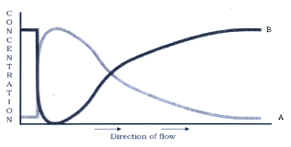

Section B

- Differentiate between perisperm and pericarp.
- Only diagrammatically represent the maturation of pro insulin into insulin.
- Keeping allergy in mind, answer the following questions:
- Which antibodies are produced during allergic reaction?
- Name any two biochemicals associated with allergy?
- Mention the name of any drug that is commonly used in allergy.
- What is an artificial chromosome? Give one example.
- Diagrammatically represent the process of transcription in eukaryotes.
- Name the hormone otherwise referred as birth hormone. What role does it play during child birth?
OR
Which layer of cells gets penetrated by the spermatozoa during fertilization? How is further sperm entry prevented?
- Fill the second column
Names of the structures | Analogous / Homologous
- Wings of bat and fore limb of horse
- Wings of bat and wings of butterfly
- Potato and sweet potato
- Tendril of cucurbita and thorn of bougainvilla

- Biofortification of cereals intends enriching the crops nutritionally. Which nutrients are improved?
- Make a diagrammatic representation of the structure of an antibody molecule.
- Look at the figure given below depicting lac operon of E. Coli. Answer the following:
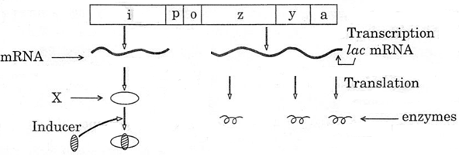
- Name the molecule ‘X’ synthesized by ‘I’ gene. How does this molecule get inactivated?
- Which one of the structural gene codes for β galactosidase?
- When will be the transcription of this gene stop?

Section C

- Starting with a barren rock, stepwise represent the successive communities till the climex community is reached. What role does the pioneering community play?
- The blastocyst is composed of which two layers? Name the layers and state their functions.
- Both detrivores and decomposers participate in detritus food chain. Give two examples each differentiate between the two.
- Sunil’s uncle is very worried as his crop is destroyed by insects. He suggests his uncle to use Bt crops. His uncle says that such crops produce toxins which can harm the consumers of this crop. Whom do you support and why?
- For amplification of genes of interest, a certain reaction plays a vital role. What is the reaction? Mention the role of Thermos aquaticus in the first step of this reaction.
- Clarify the word “cultural Eutrophication”. What are its prime sources? Name the two major contaminants that get released during this process.

Differentiate between oestrus and menstrual cycle.
- A] A man with a blood group A married a woman with B group. They have a son with blood group AB blood group and a daughter with blood group O. work out the cross and show the possibility of such inheritance.
B] Why is the possibility of a human female becoming a haemophilic extremely rare? Explain.

- MOET is a procedure that helps in cattle improvement. Sequentialise the steps of this technology. Give its full form.
OR
Fill in the empty spaces in the boxes, as per the indication in its attached column.
Name of the microbe | Name of the product
a) | Cyclosporin A
b) | Citric acid
c) | Statin
d) | Butyric acid
e) | Strepto kinase
f) | Acetic acid

Section D

- a) A mother of one year daughter wanted to space her second child. Her doctor suggested
Cu-T. Explain its contraceptive action
b) Trace the development of zygote up to its implantation in the uterus.

OR
Explain with the help of a diagram the development of the mature embryo sac from
megaspore mother cell in angiosperm.

- A) Name the type of bioreactor shown. Write the purpose for which it is used
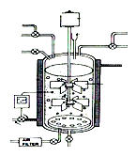

B) Answer the following question with the help of given diagram
a) What does this diagram depict?
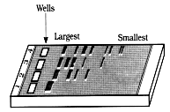
b) What is meant by largest and smallest in the picture?
c) Name the compound used to visualise them.
d) Define elution.

OR

What are the critical research areas of biotechnology? Which body governs the decisions regarding the validity of genetic modification research? With one suitable example justify how genetic engineering has given biologically useful products?

- A) Differentiate between in situ and ex situ strategies of conservation biodiversity.
B) Detailed the three major reasons why we should conserve biodiversity?

OR
In terms of conservation of biodiversity what are “Sacred groves”? Which four places in India posses them? When does species become endemic? Name two alien species that have threatened our endemic species.

